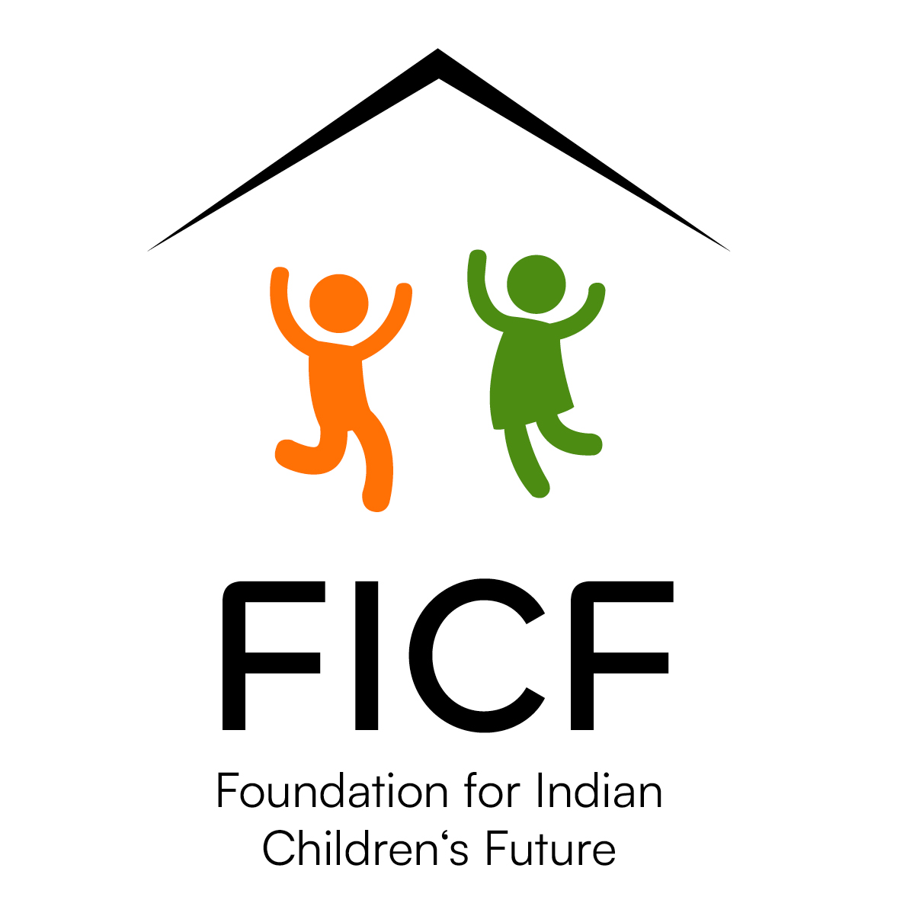

Foundation for Indian Children’s Future (FICF): Child Sponsorship

S. Jarwis John
10 May 2019
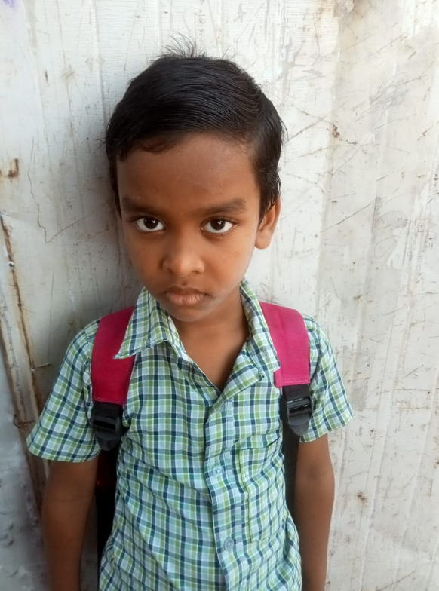

Jarwis is a 6 years old boy. He lives with his parents, two older siblings and grandparents in Palani, Tamil Nadu. He is currently studying in class 2 in a Government Municipal School, Palani.

His father is a daily wage laborer, works in a shop and his mother is a home maker. His father is the sole caretaker of the family. His grandparents are also sick and need regular medication. Due to lack of income for the family, his father struggles a lot. They don't even have the lavatory facility.

Jarwis’s father heard about FICF through Mr.Meshack approached FICF and requested financial support for his son’s education.

Foundation for Indian Children’s Future (FICF): Child Sponsorship

S. Shakklin
25 June 2007
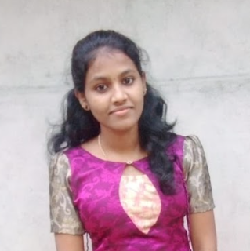

Shakklin is 19 years old. She is doing a Second year bachelor degree of Engineering in Computer Science in Kanyakumari district, Tamil Nadu. She lives with her parents and she has one older sister.

Shakklin 's father is an alcoholic and does not go for a job at all. He takes no responsibility for the family. Often she suffered from some diseases and miraculously recovered from them all.Her family is staying in a home which was damaged by a cyclone. Shakklin is in need of educational support.

In such difficult circumstances her mother came to know about FICF and reached out to FICF and requested support for Shakklin’s education.

Foundation for Indian Children’s Future (FICF): Child Sponsorship

S. Darina
15 March 2007

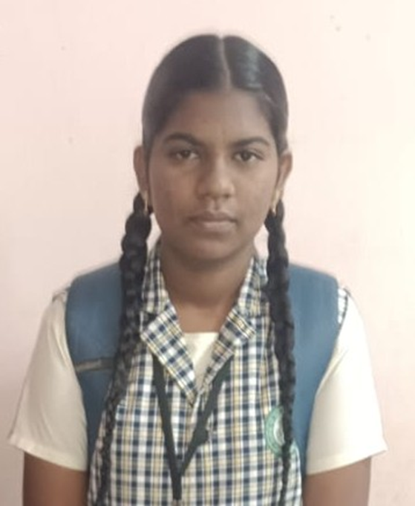

Darina is a 16-year-old orphan girl living with her uncle’s family in Eladaiyadivilai, Kanyakumari District, Tamil Nadu. She lives with her uncle, aunt, uncle’s daughter, and grandmother. Darina has completed her school education and is currently waiting to continue her higher education

As Darina does not have her parents to support her, she is concerned about the financial burden that her education and future may place on her uncle. Therefore, she humbly requests kind support for her higher education. Educational assistance would be a great help to her uncle and would enable Darina to continue her studies without becoming an additional financial burden on her family.

In such difficult circumstances her mother came to know about FICF and reached out to FICF and requested support for Darina’s education.

Foundation for Indian Children’s Future (FICF): Child Sponsorship

V. J. Jershika
23 February 2010
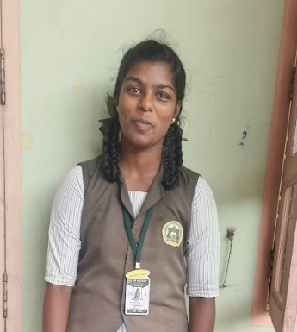

Jershika is 14 years old. She lives in Kanyakumari district, Tamil Nadu with her mother and grandmother. She is doing 9th standard in C.S.I Hacker Matriculation School which is within walking distance from her home. Her father expired 10 years back due to Jaundice. Her mother is working as a saleswoman in a nearby textiles shop.

After her father's death her mother struggles to manage the family and to take care of her child with her meager income. However her mother desires to educate her daughter in an English Medium School.

Somehow, for the 10 years her mother managed the family with the low income that she earns. Now she is not able to meet the daily needs with her income and to pay the school fees of the child. By understanding the situation, the school principal requested FICF to help Jershika for her studies so that she can continue in the same school.

Foundation for Indian Children’s Future (FICF): Child Sponsorship

P. Subhiksha
23 March 2010

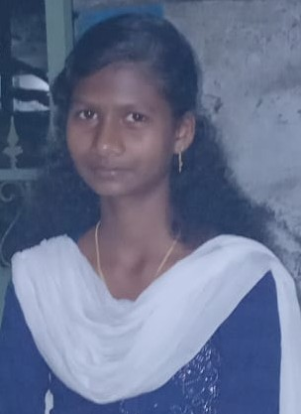
Subhiksha is a 16-year-old girl who is currently studying in Class XI at Arunachalam Higher Secondary School. She lives with her mother and younger brother in a small house in Cherupaloor, Kanyakumari District, Tamil Nadu.

Subhiksha’s father passed away, leaving her mother to take responsibility for the family. As the sole provider for the household, it has become difficult for her mother to meet the family’s daily needs and manage Subhiksha’s educational expenses.

Subhiksha is eager to continue her education and build a better future for herself. However, the financial difficulties faced by her family may become an obstacle to her studies. At this important stage of her education, the support of a sponsor would be a great blessing to Subhiksha and her family.

In such difficult circumstances her mother came to know about FICF and reached out to FICF and requested support for Subhiksha’s education.

Foundation for Indian Children’s Future (FICF): Child Sponsorship

M. Adlin Monika
17 October 2010
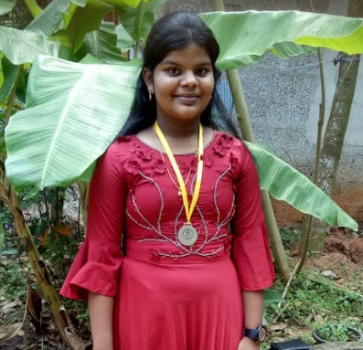

Adlin is 15 years old. She is living with her mother in Kanyakumari, Tamil Nadu. She is studying in 11 standard at St. Joseph Higher Secondary School. Her father was a mason. A few years back when her father was sitting on the bridge which is 16 feet above ground level while talking with his friends, accidentally fell down and the spinal guard was damaged. Hence her father was paralyzed and admitted in the hospital. After a few days her father expired. When her father was alive, the homemaker and her father took care of her family with much care.

Her father’s death changed the family's total situation. Her mother lost all her hope and was filled with sorrow. Now her mother has recovered, its work like a cash unit feeling for their livelihood. They don't have any other financial support. When her father was alive her parents would like to give a good education to their child, so they enrolled in a good Matriculation School. Now she is in 9th standard. Her mother faces many challenges to manage even their daily routine and he is unable to pay fees.

In such difficult circumstances her mother came to know about FICF and reached out to FICF and requested support for Monika’s education.

Foundation for Indian Children’s Future (FICF): Child Sponsorship

S. J. Arsha
16 December 2013

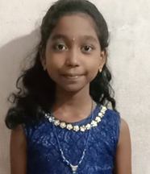
Arsha is 13 years old. She is living with her parents and siblings in Kattathurai. She is from an economically downtrodden family. Her father is a daily wage labourer. Now he has affected his spinal cord that has made him bed ridden and totally dependent on his basic care taking. This has brought the family to a miserable situation without any source of income. Her mother is a home maker. They are staying in a small house in Kattathurai. So her mother faces challenges to meet their daily needs and the children’s educational needs.

Arsha is studying in class 8 in Vivekananda Matriculation Higher Secondary School, Paraicode. She is a talented quiet girl. She is studying well. In between many difficulties, her mother paid her fee. Sometimes her mother borrows money for her education. After that her parents struggle to pay the school fee of their two children. Her older sister is one of the FICF’s sponsored students. So, her mother reached out to FICF and requested support for their daughter Arsha’s education.

Foundation for Indian Children’s Future (FICF): Child Sponsorship

Jeffy George
1 August 2006
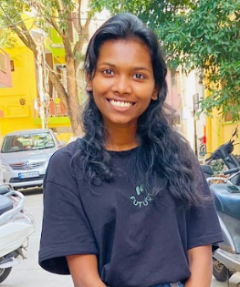

Jeffy George is 19 years old. She is studying for a second year Bachelor Degree of Nursing. There are three members in her family. She and her older sister are living with her mother. They all are living in a small rental home. Her father was a pastor in Bangalore. He met with a bike accident and died on the spot in 2013. Her Mother is taking care of the social work. Her mother receives a small amount from the ministry and they hardly meet their daily needs. By this amount, her mother is facing too many difficulties to survey the family and the education needs. No other support to their family.

In such difficult circumstances her mother came to know about FICF. They reached out to FICF and requested support for Jeffy’s education.

Foundation for Indian Children’s Future (FICF): Child Sponsorship

K. S. Kelviya Sherin Moses
12 May 2003

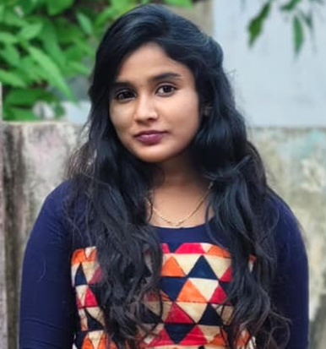
Kelviya Sherin is a 23-year-old young girl from Nachiyarvilai, Kanyakumari District, Tamil Nadu, India. She is currently pursuing her final year at Sree Ramakrishna Medical College. She lives with her mother and one younger sister in a very small rented house with limited and inadequate facilities.
Kelviya Sherin’s father abandoned the family during her childhood and later married another woman. Since then, her mother has been the sole support for the family. She works as a caretaker for elderly people and struggles to meet the family’s daily needs as well as Kelviya Sherin’s educational expenses.
However, due to her family’s financial difficulties, meeting her college fees, educational materials, and other study-related expenses has become a significant challenge. Therefore, we kindly request you to consider supporting Kelviya Sherin’s education.
In such difficult circumstances her mother came to know about FICF. They reached out to FICF and requested support for Kelviya’s education.

Foundation for Indian Children’s Future (FICF): Child Sponsorship

S. Jobu Dev
28 August 2010
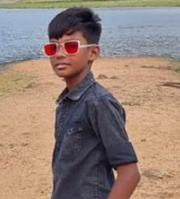

Job Dev is a 14 years old boy. He resides in Trichy, Tamil Nadu, India. He is studying in 9th standard in Nalli Matriculation School. There are 5 members in the family. He has a 6 month old sister and one adopted daughter is staying with his parents. His parents are Social workers in a village with a new church. The village people are also very poor and are unable to support the family financially. They are financially struggling in the village mission field.

He is a happy and joyful kid. He desires to become a doctor. The income of the family is very low. So his parents are struggling to meet the increasing expenses of the education of their son. Therefore, they are in need of financial assistance and requesting FICF for an educational support to their son’s education.

Foundation for Indian Children’s Future (FICF): Child Sponsorship

J. Abima
14 November 2011
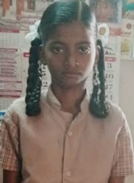

Abima is a 13 years old girl. She lives with her father and two older sisters in Palani, Tamil Nadu. She is currently studying in class 8 in Municipal School, Palani.

Her father is a daily wage laborer and works in a brick kiln. Her mother died of Tuberculosis in 2019. The family was left all alone and her father is the sole caretaker of the family. Due to lack of income for the family, Abima had to leave her previous school as her father couldn't afford to pay the high school fees. Her uncle’s family is taking care of her and her two sisters but there is no one to support them financially.

Abima’s father heard about FICF through Mr. Meshack approached FICF and requested financial support for his daughter Abima’s education.

Foundation for Indian Children’s Future (FICF): Child Sponsorship

Davin Joseph Paul
10 October 2007
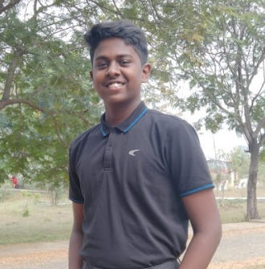

Davin is 17 years old. He is living with his parents in Maharashtra, India. He has an older sister. His sister is in her degree course. He is studying for a BA in Political Science and Sociology at Kristu Jayanti College, Bangaluru . He desires to become an IAS officer.His native is Kerala, the southern tip of India. His parents are working as social workers in north India for more than twenty years and the kids were born in Kerala but were raised in north India. They speak three languages: Malayalam, Hindi and English. A few Years back his parents resigned from the team that they were working with and moved to the outskirts of Nagpur city which is in Maharashtra state.

The income of the family is very low. So his parents are struggling to meet the increasing expenses of the education of their son. Since they work cross-culturally, they don’t have an option other than sending their son to a private English Medium School. Even though the school he goes to is one of the cheapest in their area, it is too expensive for them. Therefore, they are in need of financial assistance and requesting FICF for an educational support to their son’s education.

Foundation for Indian Children’s Future (FICF): Child Sponsorship

C. Pavithra
24 March 2006
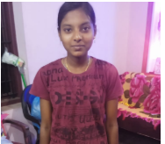

Pavithra is 20 years old. She is living with her grandmother in Kanyakumari district of Tamil Nadu. She has one younger sister. Her parents abandoned their children and married another person. Now her parents don’t have any contact with her family. Her grandmother is taking care of her daily needs and school studies. Her uncle was a little bit supportive. Her grandmother did not go to a regular job because of her old age problems. So her grandmother faces challenges to meet their daily needs and her educational needs.

Pavithra is doing a second year of the Diploma in Nursing at Government Thoothukudi Medical College. She is a very silent girl. She is interested in studies and sports activities. She always scores good marks in her examinations. She likes to get a responsible position in her future. Her grandmother wishes to raise Pavithra as an educated and disciplined person. So they graduated people in society. In between many difficulties, her grandmother paid her fees. Sometimes her grandmother borrows money for her education. In this situation, through one of the FICF staff, her grandmother came to know about FICF. Then his grandmother reached out to FICF and requested support for their granddaughter Pavithraś education.

Foundation for Indian children’s Future (FICF): Child Sponsorship

Agnes Prodicil Bensam
09 March 2005

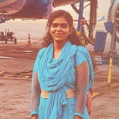

Agnes is 21 years old. She is living with her mother and older brother in Kanyakumari district, Tamil Nadu. She completed her bachelor degree in physiotherapy and is waiting for an internship. Her father was working in Saudi Arabia and expired during the COVID period. After that her mother is facing many difficulties raising their children and managing their educational needs. So she reached out to FICF to support Agnes’s education.

Foundation for Indian children’s Future (FICF): Child Sponsorship

Bennitta Prabakar
24 January 2006

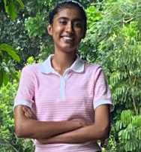

Bennitta is a 20-year-old student currently pursuing her final year of B.Sc. Psychology at Sacred Heart College, Tiruppattur. As her college is away from her home, she resides in the college hostel.
Bennitta’s parents are social workers and live in Tirunelveli District, Tamil Nadu. They have a modest income, which makes it very difficult for them to meet the family’s day-to-day expenses while also supporting the education of both their children. Bennitta has a younger sister who is currently pursuing her bachelor’s degree.
Given the family’s limited financial resources and the increasing educational expenses, Bennitta’s parents approached FICF seeking financial assistance to support Bennitta’s education and her further studies. The requested support would help ease the financial burden on her parents and enable Bennitta to continue and complete her education without interruption.

Foundation for Indian children’s Future (FICF): Child Sponsorship

Bettina Prabakar
26 September 2007

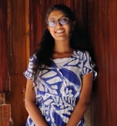

Bettina is a 19-year-old student currently pursuing her first year of B.Sc. Nursing at the College of Nursing, CMC Vellore. Since her college is located away from her home, she is residing in the college hostel.
Bettina’s parents are social workers and live in Tirunelveli District, Tamil Nadu. They have a modest income, and meeting the family’s day-to-day expenses while supporting the education of both their children is financially challenging. Bettina has an older sister who is currently pursuing her bachelor’s degree.
Considering the family’s limited financial resources and the expenses involved in Bettina’s nursing education, her parents are seeking financial assistance to support her studies. Such support would help reduce the financial burden on the family and enable Bettina to continue her nursing education and work towards a meaningful career in the healthcare sector.

Foundation for Indian children’s Future (FICF): Child Sponsorship

M. Gladson Andrew
04 June 2006

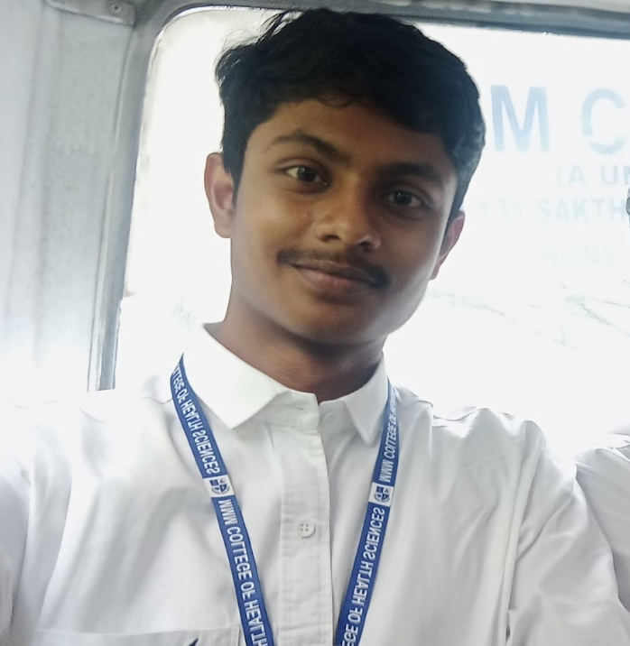

Gladston is 20 years old. He is living with his parents and brother Steve. He is pursuing his third year Bachelor degree in Cardiac Technology. This is a cross-cultural missionary family serving the Lord for more than 20 years. They are originally from Tamil Nadu. For the last 5 years, they have worked as independent missionaries, working in Kerala villages, estates, hospitals, and in cottages. Evangelizing and guiding them to nearby churches now and then, they helped them materially in all the ways they could.

While everything was going well, less than a year ago, his father met with an accident, a lorry hit his bike. His father fell down and got injuries to his inner organs. Though his father is alright, he lost 25% of his touch sense on his full left side, from head to toe. Therefore, he could not go to his ministries or even do his daily responsibilities. At present, he is at home and doing whatever ministry he can. His mother is working in a nearby office trying to help the family. Yet, they are serving the Lord passionately in both the villages and towns. They really struggle to drop the children to pay rent, and meet daily home needs.

In this situation his parents came to know about FICF by his family person and reached out to FICF and requested support for Gladson’s education

Foundation for Indian children’s Future (FICF): Child Sponsorship

S. Haristha
06 June 2018

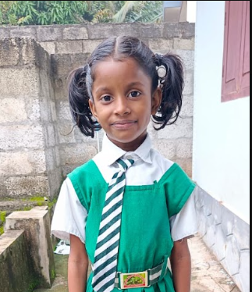

Haristha is 8 years old. She is living with her parents and siblings in Kozhipoorvilai. She is from an economically downtrodden family. Her father is a daily wage laborer and her mother is a home maker. They are staying in a rented house in Kozhipoorilai. Her father did not have a regular job. So her father faces challenges to meet their daily needs and the children’s educational needs. Her mother is taking treatment for some uterus problems.

Harshitha is studying 2nd standard in Infant Jesus High School, Mulagumoodu. She is a talented quiet girl. She studies well. She likes to spend time with her sisters. She always scores good marks in her examinations.

Her parents have just finished their primary schooling and they wish to raise their children as educated and disciplined persons. So they enrolled in a good matriculation school. In between many difficulties, her parents paid her fee. Sometimes her parents borrow money for her education. After that her parents struggle to pay the school fee of their three children. So her parents planned to change the kids into the Tamil Medium School. In this situation, through one of the FICF staff, her parents came to know about FICF. Then her parents reached out to FICF and requested support for their daughter Harshitha’s education.

Foundation for Indian children’s Future (FICF): Child Sponsorship

A. Steve Austin
17 August 2010

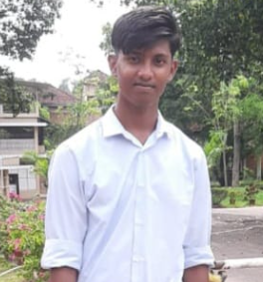

Steve is 16 years old and is living with his parents and older brother Gladson. He is studying 11th standard.This is a cross-cultural missionary family serving the Lord for more than 20 years. They are originally from Tamil Nadu. For the last 5 years, they have worked as independent missionaries, working among Kerala villages, estates, hospitals, and in cottages, evangelizing and guiding them to nearby churches. Now and then, they help them materially in all the ways they could.

While everything was going well, less than a year ago, his father met with an accident, a lorry hit his bike. His father fell down and got injuries to his inner organs. Though his father is alright, he lost 25% of his touch sense on his full left side, from head to toe. Therefore, he could not go to his ministries or even do his daily responsibilities. At present, he is at home and doing whatever ministry he can. His mother is working in a nearby office trying to help the family. Yet, they are serving the Lord passionately in both the villages and towns. They really struggle to drop the children to school back and forth, pay rent, and meet daily home needs.

In this situation his parents came to know about FICF by his family person and reached out to FICF and requested support for Austin’s education.

Foundation for Indian children’s Future (FICF): Child Sponsorship

S. Mathan Prasad
04 April 2006
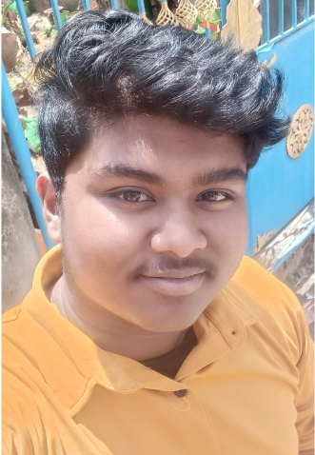

Mathan Prasad is 20 years old and hails from Kanyakumari District, Tamil Nadu. He completed his schooling in the district with the support of FICF. He is currently pursuing his fourth year of a Bachelor’s Degree in Architecture at a college near Namakkal, Tamil Nadu. Mathan comes from a financially struggling family. He has a twin sisters and both of his twin sisters are currently pursuing their first year of Bachelor’s Degrees in Civil Engineering.
Mathan’s father has been partially disabled following a stroke for more than 16 years and is unable to contribute significantly to the family’s income. As a result, his mother is the sole breadwinner of the family. She has to manage the household expenses, her husband’s medical needs and the educational expenses of all three children.
Meeting the educational expenses of three children while also managing the family’s medical and daily living needs has become a significant financial burden for her. Despite these challenges, she is determined to support her children in completing their higher education.
Therefore, his mother has humbly requested financial assistance to support Mathan’s education and help him complete his Bachelor’s Degree in Architecture. Your support would greatly reduce the financial burden on his family and enable Mathan to continue his studies without interruption and work toward a better future.

Foundation for Indian children’s Future (FICF): Child Sponsorship

S.Ramya
30 December 2008

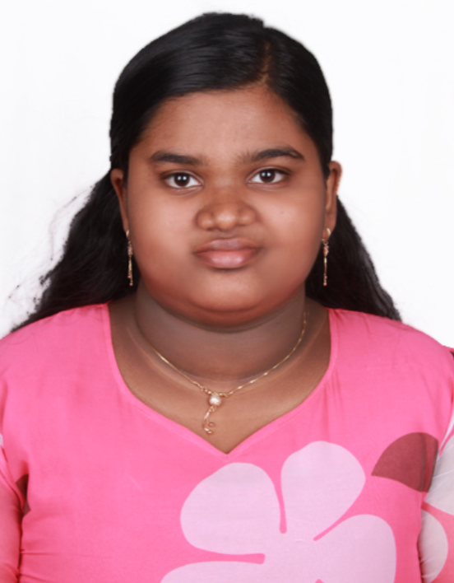

Ramya is 17 years old and hails from Kanyakumari District, Tamil Nadu. She completed her schooling in the district with the support of FICF. She is currently pursuing her first year of a Bachelor’s Degree in Civil Engineering in Ponjesley College of Engineering in her district. She comes from a financially struggling family. She has a twin sister and an older brother, both of her siblings are currently pursuing their Bachelor’s Degrees.

Her father has been partially disabled following a stroke for more than 16 years and is unable to contribute significantly to the family’s income. As a result, her mother is the sole breadwinner of the family. Her mother has to manage the household expenses, her husband’s medical needs and the educational expenses of all three children.

Meeting the educational expenses of three children while also managing the family’s medical and daily living needs has become a significant financial burden for her mother. Despite these challenges, her mother is determined to support her children in completing their higher education.Therefore, her mother has humbly requested financial assistance to support Ramya’s education and help her complete her Bachelor’s Degree in Civil Engineering. Your support would greatly reduce the financial burden on her family and enable Ramya to continue her studies without interruption and work toward a better future.

Foundation for Indian children’s Future (FICF): Child Sponsorship

S.Sowmya
30 December 2008

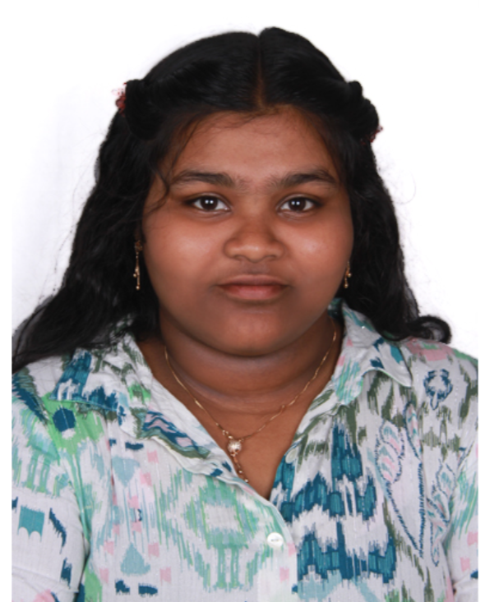

Sowmya is 17 years old and hails from Kanyakumari District, Tamil Nadu. She completed her schooling in the district with the support of FICF. She is currently pursuing her first year of a Bachelor’s Degree in Civil Engineering in University College of Engineering, Tuticorin in Tamil Nadu. She has diabetes and takes insulin twice a day, in the morning and at night. She comes from a financially struggling family. She has a twin sister and an older brother, both of her siblings are currently pursuing their Bachelor’s Degrees.

Her father has been partially disabled following a stroke for more than 16 years and is unable to contribute significantly to the family’s income. As a result, her mother is the sole breadwinner of the family. Her mother has to manage the household expenses, her husband& daughter’s medical needs and the educational expenses of all three children.

Meeting the educational expenses of three children while also managing the family’s medical and daily living needs has become a significant financial burden for her mother. Despite these challenges, her mother is determined to support her children in completing their higher education. Therefore, her mother has humbly requested financial assistance to support Sowmya’s education and help her complete her Bachelor’s Degree in Civil Engineering. Your support would greatly reduce the financial burden on her family and enable Sowmya to continue her studies without interruption and work toward a better future.

Foundation for Indian children’s Future (FICF): Child Sponsorship

V. Ashmiya
26 October 2013

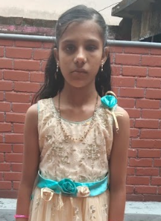

Ashmiya is 14 years old. She is living with her parents and siblings in Pandivilai. She is from an economically downtrodden family. Her father is a daily wage laborer and he is sick, her mother is a housewife. They are staying in their grandmother’s house in Pandivilai. Her father did not have a regular job. So her father faces challenges to meet their daily needs and the children’s educational needs.

She is studying in class 8 at LMS Higher Secondary School, Kadamalaikuntu. She is a quiet and talented girl. She is studying very well. She likes to spend time with her brother. She always scores good marks in her examinations.

Although her parents are illiterate, they want their children to study well in the English medium school. But due to the poor family environment, they have sent their children to study Tamil medium school. However, they are not even able to buy notebooks and uniforms and are seeking this scholarship in the hope of getting some help . Her parents wished to raise their children as educated and disciplined persons. During this time they came to know about the educational sponsorship of FICF through the Vilavoor Panchayat president Mr.Bilkan. Then her parents reached out to FICF and requested support for their daughter Asmiya’s education.

Foundation for Indian children’s Future (FICF): Child Sponsorship

B. Daisy
14 February 2019

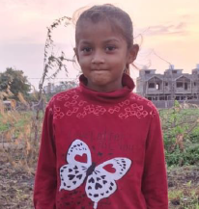

Daisy is a 7 years old girl. She lives with her parents and her siblings in Amreli, Gujarat. She has 2 younger sisters. She is studying in class 2 in Sri Bhojalpara Prathmikshala, Amreli. She is so interested in studies.

Daisy is a little girl who started her education in a very poor environment. Her mother was an orphan. When her father married her mother, her father’s family neglected them and never supported them.

Daisy’s parents struggle to provide basic needs and education to the three daughters..They are economically downtrodden. In this situation, her parents knew about FICF through Mr. Ebinese Kannan, approached FICF and requested financial support for their daughter’s education.

Foundation for Indian children’s Future (FICF): Child Sponsorship

V. N. Dharshini
06 October 2008

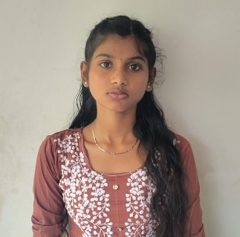

Dharshini is a 17 years old girl. She is living with her mother and her siblings in Kanyakumari District, Tamil Nadu. Before 5 years, her father abandoned the family and unlawfully married another woman. Her mother is doing daily wage work. They are staying in a small house which has inadequate facilities.

Dharshini completed her class 12 in Amala Convent Girls Higher Secondary School with 82%. of marks. Now she has applied for a bachelor degree in Nursing and is waiting for counseling. She is a very talented and active girl. As an uneducated and helpless woman, the fee in the school is not affordable by her mother and continue her studies.

Her mother has no other support. Her mother is struggling too much to meet the daily needs of the family and kids' studies. In such a situation, through one of the neighbors, her grandmother came to know about FICF. Then her mother reached out to FICF and requested support for Dharshini to continue her studies in the same school.

Foundation for Indian children’s Future (FICF): Child Sponsorship

G. L. Ansiga
20 February 2015
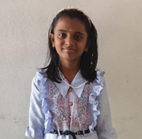

Ansiga is 11 years old. Ansiga and her mother are living with her grandparents in Pilankalai, Kanyakumari district of Tamil Nadu. Her mother is a daily wage worker.

Ansiga is studying in class 6 in Government High School, Moolachel. She is a bright and hardworking child. Sadly, her father abandoned the family just 52 days after her birth and remarried another woman. Her mother, who is physically handicapped, works as a daily wage laborer to take care of her. Their extended family also struggles with poverty and cannot offer much support.

In such a situation her mother heard about FICF through Mr. Bilcon, a local panchayat president, approached FICF and requested financial support for her daughter’s education.

